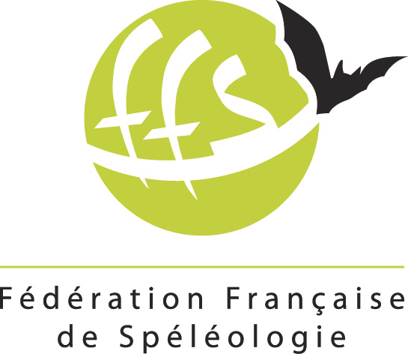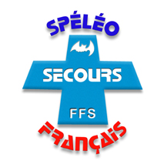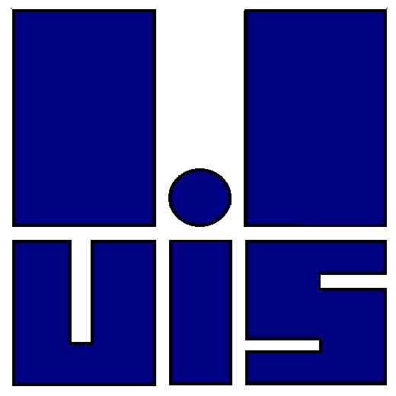
International Cave-Rescue Meeting
The 6th European meeting of Alpin Karst Countries
Châtel de Joux - Jura - France –
Centre de l’AVEL – lieu dit Crochère
18th to 21th October 2012
The cave rescue commission of Jura department is organizing for the Union International of Speleology the 6th European meeting for specialized teams in Cave-Rescue called before «Meeting of Alpin Karst Countries »

This meeting will be held from Thursday 18 to Sunday 21 October to “Châtel de Joux” near the border of Regional Natural Park of “Haut Jura” and the “Country of Lakes”, France. More than 10 nations will be representing by specialist cavers.
After the theme « Materials ‐ Techniques and tests » we saw in 2011 at the Croatia meeting, we will develop this year:
- The rescue in cave-diving,
- The medical aspects and the pathologies concerning diving and moving obstruction,
- Moving obstruction (widening a way allowing evacuation of a stretcher) and the management of gaz.
PROGRAM:
Thursday 18: you can arrive and first welcome-aperitif will be at 19h. After the dinner: practice organization of the WE.
Friday 19: Inside the Center of Avel, we have three places with video-projector for several communications. Each country presents his organization concerning Diving rescue, moving obstruction with or without explosive, medical aspects concerning diving and gas of explosive.
Saturday 20: Application “in situ”. We have a lake at 1 kilometer, lapiaz rock at 1 km and half. It is possible to put in place the different technics.
17h to 19h meeting of ECRA.
Sunday 21: report in assembly with results of doctors.
We have needed to know by country:
Number for diving: _______________
Number for moving obstruction: _________
Number for medical aspects: _________________
Others: _________________________
Arrive: Thursday afternoon or Friday morning.
From plane to Geneve you can arrive after by train to Lons le Saunier in Jura and since this town we can organize to pick up you. At what day and hour do you arrive: ________________
Contact by phone: Wim: + 33 6 01 99 38 01 (Wim speak English and can answer if you have a problem to join us in your travel).
Thank you to send me by mail your last option. Christian DODELIN: christian.dodelin@sfr.fr
Best regards
Christian Dodelin

